**Lab Report: 02**

**Title: Scan Conversion (Circle and Ellipse)**

*Course title: Computer Graphics Laboratory*

*Course code: CSE-304*

*3rd Year 1st Semester Examination 2022*

**Date of Submission**: 04/06/2023



**Submitted to-**

*Dr. Mohammad Shorif Uddin*

*Professor*

*Department of Computer Science and Engineering*

*Jahangirnagar University*

*&*

*Dr. Morium Akter*

*Associate Professor*

*Department of Computer Science and Engineering*

*Jahangirnagar University*

*Savar, Dhaka-1342*

|  |  |  |
| --- | --- | --- |
| Class Roll | Exam Roll | Name |
| 353 |  | Shanjida Alam |

**Experiment 01: Scan Conversion of a Circle Using Midpoint Algorithm**

**Source Code:**

#include <bits/stdc++.h>

#include <graphics.h>

using namespace std;

void drawCircle(int xc, int yc, int r) {

int x = 0;

int y = r;

int d = 1 - r;

while (x <= y) {

putpixel(xc + x, yc + y, BLUE);

putpixel(xc - x, yc + y, BLUE);

putpixel(xc + x, yc - y, BLUE);

putpixel(xc - x, yc - y, BLUE);

putpixel(xc + y, yc + x, BLUE);

putpixel(xc - y, yc + x, BLUE);

putpixel(xc + y, yc - x, BLUE);

putpixel(xc - y, yc - x, BLUE);

if (d >= 0) {

y--;

d += 2 * (x - y) + 1;

} else {

d += 2 * x + 1;

}

x++;

}

}

int main()

{

int x,y,r;

cout<<"Enter the center coordinates (x, y): ";

cin>>x>>y;

cout<<"Enter the radius (r): ";

cin>>r;

int gd = DETECT, gm;

initgraph(&gd, &gm, "");

drawCircle(x,y,r);

delay(5000);

getch();

closegraph();

return 0;

}

**Output:**

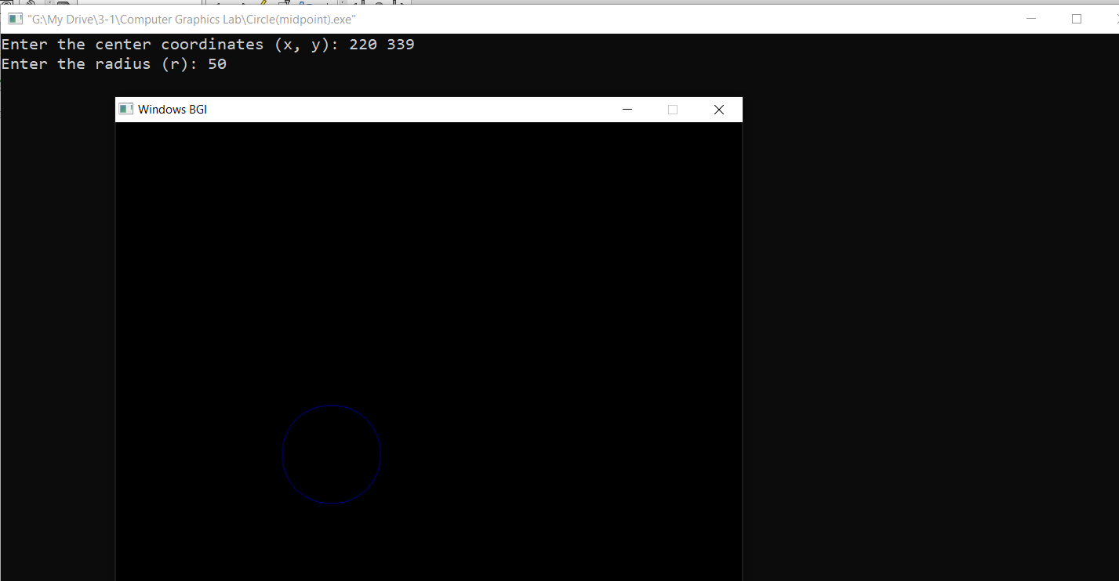

**Experiment 02: Scan Conversion of a Ellipse Using Midpoint Algorithm**

**Source Code:**

#include <iostream>

#include <graphics.h>

using namespace std;

void drawEllipse(int xc, int yc, int rx, int ry)

{

int x = 0;

int y = ry;

int d1 = (ry * ry) - (rx * rx * ry) + (0.25 * rx * rx);

int dx = 2 * ry * ry * x;

int dy = 2 * rx * rx * y;

while (dx < dy)

{

putpixel(xc + x, yc + y, WHITE);

putpixel(xc - x, yc + y, WHITE);

putpixel(xc + x, yc - y, WHITE);

putpixel(xc - x, yc - y, WHITE);

if (d1 < 0)

{

x++;

dx = dx + (2 * ry * ry);

d1 = d1 + dx + (ry * ry);

}

else

{

x++;

y--;

dx = dx + (2 * ry * ry);

dy = dy - (2 * rx * rx);

d1 = d1 + dx - dy + (ry * ry);

}

}

int d2 = ((ry * ry) * ((x + 0.5) * (x + 0.5))) + ((rx * rx) * ((y - 1) * (y - 1))) - (rx * rx * ry * ry);

while (y >= 0)

{

putpixel(xc + x, yc + y, WHITE);

putpixel(xc - x, yc + y, WHITE);

putpixel(xc + x, yc - y, WHITE);

putpixel(xc - x, yc - y, WHITE);

if (d2 > 0)

{

y--;

dy = dy - (2 * rx * rx);

d2 = d2 + (rx * rx) - dy;

}

else

{

y--;

x++;

dx = dx + (2 * ry * ry);

dy = dy - (2 * rx * rx);

d2 = d2 + dx - dy + (rx * rx);

}

}

}

int main()

{

int xc, yc, rx, ry;

cout << "Enter the center coordinates (x,y): ";

cin >> xc >> yc;

cout << "Enter the major radius (rx): ";

cin >> rx;

cout << "Enter the minor radius (ry): ";

cin >> ry;

int gd = DETECT, gm;

initgraph(&gd, &gm, "");

drawEllipse(xc, yc, rx, ry);

delay(10000);

getch();

closegraph();

return 0;

}

**Output:**

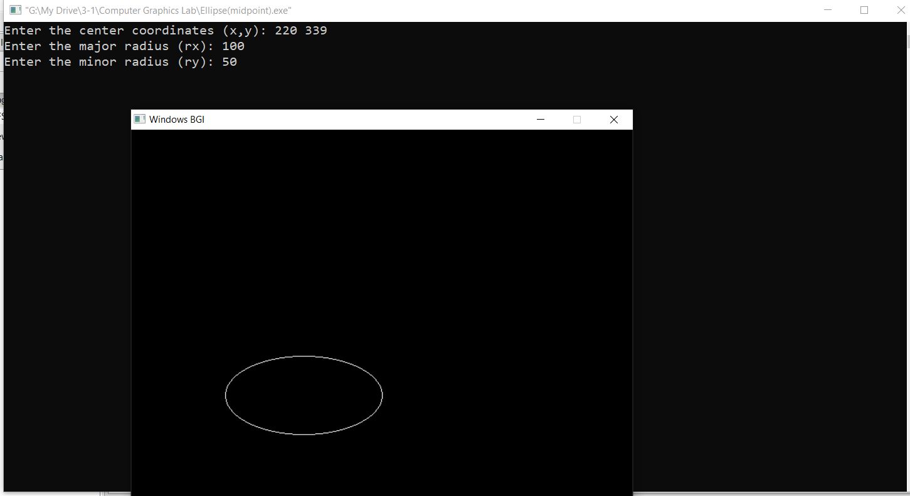

**Experiment 03: Scan Conversion of a Ellipse Using Trigonometric Equation**

#include <bits/stdc++.h>

#include <graphics.h>

using namespace std;

void drawEllipse(int xc, int yc, int rx, int ry)

{

int numPoints = 360;

double angleIncrement = (2*3.1416)/numPoints;

for (int i = 0; i < numPoints; ++i)

{

double angle = i * angleIncrement;

int x = xc + round(rx * cos(angle));

int y = yc + round(ry * sin(angle));

putpixel(x, y, WHITE);

}

}

int main()

{

int xc, yc, rx, ry;

cout << "Enter the center coordinates (xc, yc): ";

cin>>xc>>yc;

cout<<"Enter the major radius (rx): ";

cin>>rx;

cout<<"Enter the minor radius (ry): ";

cin>>ry;

int gd = DETECT, gm;

initgraph(&gd, &gm, "");

drawEllipse(xc, yc, rx, ry);

delay(5000);

getch();

closegraph();

return 0;

}

**Output:**

